HC 1 T2 U1
 | 題目 | 圖片
1 | I can jump. | 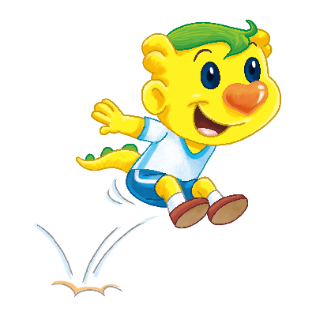
2 | I can run. | 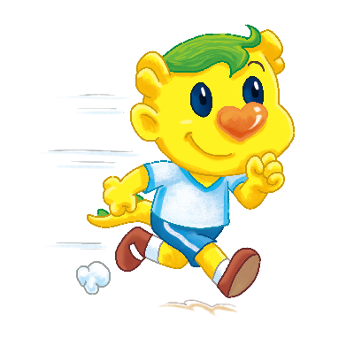
3 | I can walk. | 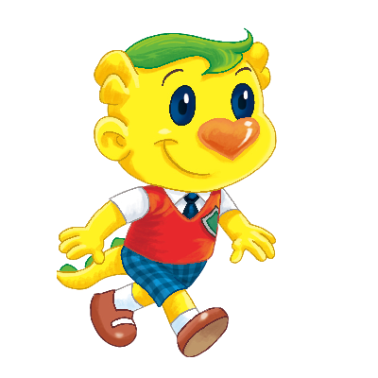
4 | I can dance. | 